**Physical Database Implementation And Stored Procedures**

**Conceptual Design (ERD)**

**Updated ERD:**

**Relationship Diagram From SQL Server**

* A Land can have 1 or many plants and a plant can be present in 0 or many lands.
* A plant can be grown in 1 or many seasons and a season can be used to grow 1 or many plants.
* A Land must have only one Landowner and a LandOwner can own one or more lands.
* A Land can have only one LandManager and a landmanager can be allotted to only one land.
* A plant can require one or more fertilizers
* A plant can give only one product and a product belongs to a single type of plant.
* A land requires one or more equipment and an equipment can be used in 0 or more lands.
* A land can have 1 or more residents but a resident belongs to only one land

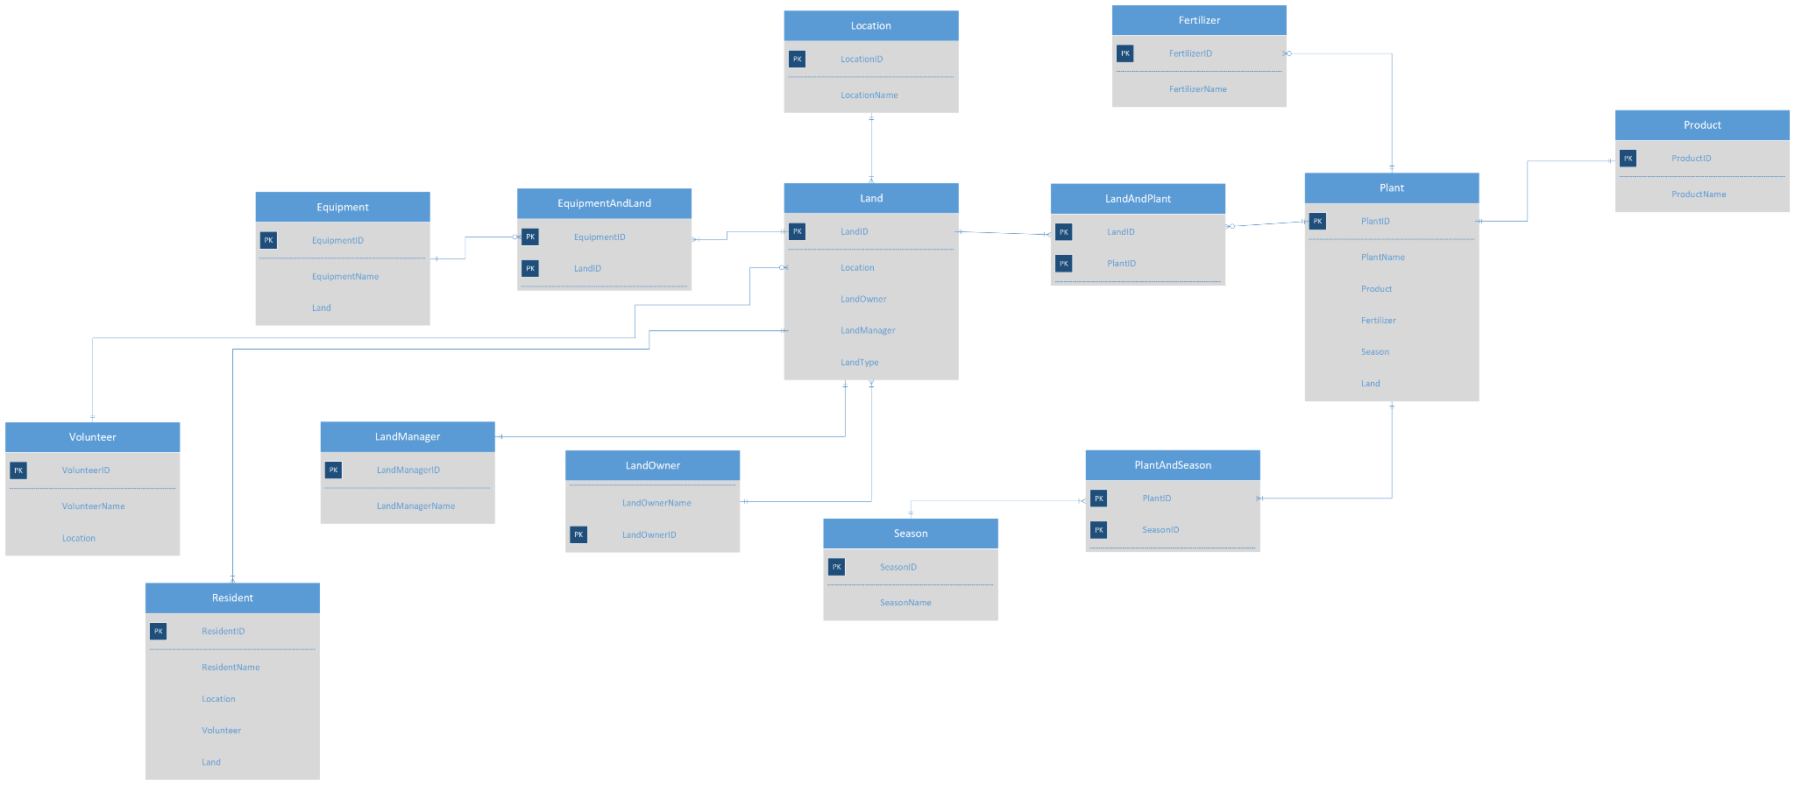

**Database Diagram**

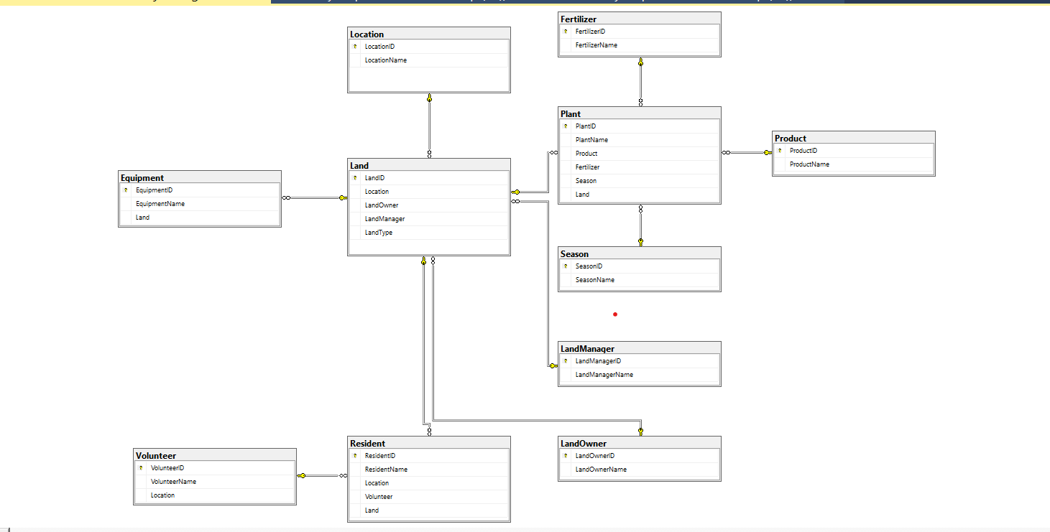

**Data Dictionary**

**Data Dictionary for X Boarding School Database**

**Tables**

Equipment = represents the equipment that is used for community gardeningcourses that are offered at the school

Fertilizer = represents the fertilizer that is being used for the plants in accordance with the land type

LandManager = represents the people who manage and coordinate the community gardens

LandOwner = represents the data of all the Land details such as Land type, location.

Land = the data of people who contributed the lands for community gardening

Plant = represents the details of plants grown in the community garden

Product = represents the details of plant produce and the associated nutritional content

Resident = represents the data of residents who participate in the community gardening

**Equipment**

|  |  |  |  |  |  |
| --- | --- | --- | --- | --- | --- |
| **Attribute Name** | **Key Type  (if any)** | **Definition** | **Data Type** | **Required**  **(Y/N)** | **Constraints  (if any)** |
| EquipmentID | PK | Unique identifier for the equipment | INT | Y | Unique.  Cannot be more than 4 digits. |
| Land |  | The identifier for the Land used for gardening. | VARCHAR(100) | Y |  |
| Equipment Name |  | Name of the equipment | VARCHAR(100) | Y |  |

**Fertilizer**

|  |  |  |  |  |  |
| --- | --- | --- | --- | --- | --- |
| **Attribute Name** | **Key Type  (if any)** | **Definition** | **Data Type** | **Required**  **(Y/N)** | **Constraints  (if any)** |
| FertilizerID | PK | The identifier for the fertilizer used in community gardening. | INT | Y | Unique.  Value. |
| FertilizerName |  | Name of the fertilizer | VARCHAR(150) | Y |  |

**LandManager**

|  |  |  |  |  |  |
| --- | --- | --- | --- | --- | --- |
| **Attribute Name** | **Key Type  (if any)** | **Definition** | **Data Type** | **Required**  **(Y/N)** | **Constraints  (if any)** |
| LandManagerID | PK | The identifier for the manager of the community gardening inside the residence hall | INT | Y | Unique  Value. |
| LandManagerName |  | Name of the Manager | VARCHAR(150) | Y |  |

**Land**

|  |  |  |  |  |  |
| --- | --- | --- | --- | --- | --- |
| **Attribute Name** | **Key Type  (if any)** | **Definition** | **Data Type** | **Required**  **(Y/N)** | **Constraints  (if any)** |
| LandID | PK | The identifier for the ID of the lands available | INT | Y | Unique.  Value. |
| Location |  | Location | VARCHAR(150) | Y |  |
| LandOwner | FK | Owner of the Land | VARCHAR(50) | Y |  |
| LandManager |  | Manager of the Land | VARCHAR(50) | Y |  |

**LandOwner**

|  |  |  |  |  |  |
| --- | --- | --- | --- | --- | --- |
| **Attribute Name** | **Key Type  (if any)** | **Definition** | **Data Type** | **Required**  **(Y/N)** | **Constraints  (if any)** |
| LandOwnerID | PK | The identifier for the Owner of the Land | INT | Y | Unique.  Value. |
| LandOwnerName |  | Name of the Owner | VARCHAR(50) | Y |  |

**Plant**

|  |  |  |  |  |  |
| --- | --- | --- | --- | --- | --- |
| **Attribute Name** | **Key Type  (if any)** | **Definition** | **Data Type** | **Required**  **(Y/N)** | **Constraints  (if any)** |
| PlantID | PK | The identifier for the plant | INT | Y | Unique.  Value. |
| PlantName |  | The identifier of the Plant Name | VARCHAR(150) | Y |  |
| Product |  | The identifier of the plant product | VARCHAR(150) | Y |  |
| Fertilizer |  | The identifier of the Fertilizer | VARCHAR(150) | Y |  |
| Season |  | The identifier of the Season | VARCHAR(50) | Y |  |
| Land |  | The identifier of the Land | VARCHAR(50) |  |  |

**Product**

|  |  |  |  |  |  |
| --- | --- | --- | --- | --- | --- |
| **Attribute Name** | **Key Type  (if any)** | **Definition** | **Data Type** | **Required**  **(Y/N)** | **Constraints  (if any)** |
| ProductID | PK | The identifier for the product obtained | INT | Y | Unique.  Value. |
| ProductName |  | The identifier of the Product name | VARCHAR(150) | Y |  |

**Resident**

|  |  |  |  |  |  |
| --- | --- | --- | --- | --- | --- |
| **Attribute Name** | **Key Type  (if any)** | **Definition** | **Data Type** | **Required**  **(Y/N)** | **Constraints  (if any)** |
| ResidentID | PK | The identifier for the participating resident in the community | INT | Y | Unique.  Value. |
| ResidentName |  | The name of the resident | VARCHAR(150) | Y |  |
| Location |  | Location of the resident | VARCHAR(150) | Y |  |
| Volunteer |  | The identifier of the volunteer | VARCHAR(50) | Y |  |
| Land |  | The identifier of the Land | VARCHAR(50) | Y |  |

**Season**

|  |  |  |  |  |  |
| --- | --- | --- | --- | --- | --- |
| **Attribute Name** | **Key Type  (if any)** | **Definition** | **Data Type** | **Required**  **(Y/N)** | **Constraints  (if any)** |
| SeasonID | PK | The identifier for the season | INT | Y | Unique.  Value. |
| SeasonName |  | The name of the season | VARCHAR(100) | Y |  |

**Volunteer**

|  |  |  |  |  |  |
| --- | --- | --- | --- | --- | --- |
| **Attribute Name** | **Key Type  (if any)** | **Definition** | **Data Type** | **Required**  **(Y/N)** | **Constraints  (if any)** |
| VolunteerID | PK | The identifier for the volunteer guiding the residents. | INT | Y | Unique.  Value. |
| VolunteerName |  | The name of the volunteer | VARCHAR(150) | Y |  |
| Location |  | Address of the volunteer | VARCHAR(150) | Y |  |